Earned Value Analysis

Project 2010 provides still another way to track and analyze your project’s performance. The Earned Value Analysis feature will help you compare your original project plan with what has actually been done, to help you find out if your costs, task completion, and schedule are progressing as you originally planned.

About EVA
Project’s Earned Value Analysis (EVA) features can help you view a project’s actual and planned cost and work, and the variances between the two. It can also show you schedule variances.

Basically, Project looks at the following four entities when calculating EVA:
- Your project baseline
- Your actual work and costs
- The variances between baseline data and actual data
- The status date (as specified in the Project Information dialogue)

By this time, you should already know how to save a baseline for your project and how to enter actual data, so let’s proceed by getting right into the subject of EVA.

Viewing EVA Tables
In Project, you can view the Earned Value Analysis for either tasks or resources. To view the EVA for resources, make sure that you are in Resource Sheet view. To view the EVA for tasks, make sure that you are in a task sheet (like the Task Entry table for example). For our purposes, we’ll stick with viewing the EVA for tasks.

You may also want to set a Project Status date by clicking the Project ribbon, followed by the Project Information button. You can than specify a status date in the Project information dialogue which will be used as a cut-off point for the EVA (as EVA will be calculated up to the Status date). By default, the Project status date will be the current date, unless otherwise specified.

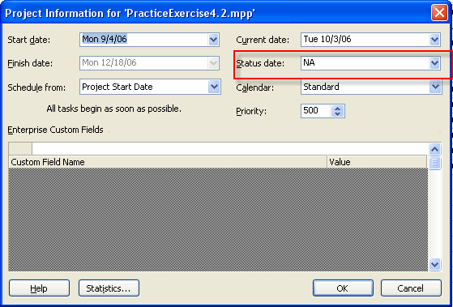

Remember to click the OK button to implement any change that you make.

Next, click the View ribbon, from the Data group click Table, and click More Tables. Now, you can choose from one of the three EVA tables available.

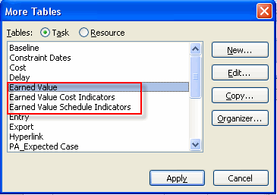

- The “Earned Value” table will give you an overview of the work, cost, schedules, and estimates for your tasks.
- The “Earned Value Cost Indicators” table will focus more on cost budgets, variances, and estimates.
- The “Earned Value Schedule Indicators” table will focus on schedule budgets and variances.

The following image shows an example of a basic “Earned Value” table.

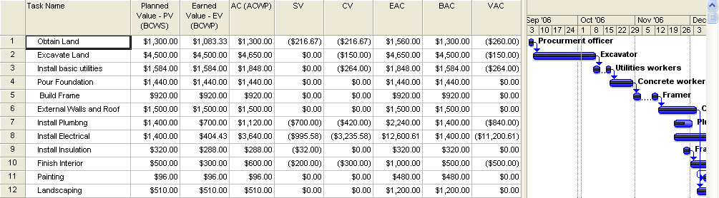

Here is a closer view of the table itself.

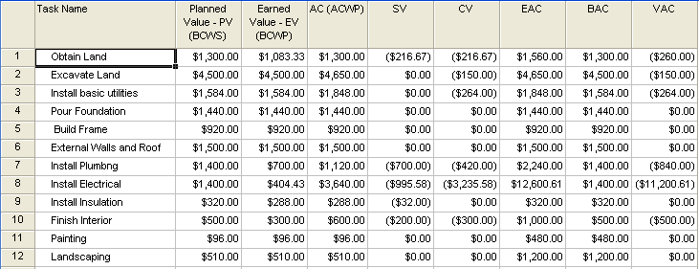

Clearly, there is a lot of information presented here. The question now becomes, how do we interpret the data in the EVA table?

A good start to answering this question is to understand what the different field names (column headings) mean.

About the EVA Fields
Before we can really understand what the EVA table is telling us, we must understand what the column headings in the table mean. The following chart shows what the EVA column headings stand for, and what the values in the fields show.

Abbreviation | What it stands for | What it shows | Formula
BCWS | Budgeted Cost of Work Scheduled | This is what should be spent (baseline) on a task up to the status date. | N/A
BCWP | Budgeted Cost of Work Performed | The cost of work corresponding to % completed on the task, according to the original budget (baseline). | N/A
ACWP | Actual Cost of Work Performed | The sum of all costs for work performed on a task to date. | N/A
CV | Cost Variance | The difference between how much was budgeted for the task’s performed work (BCWP), and how much the task actually costs (ACWP). | BCWP - ACWP
SV | Schedule Variance | The difference between how much was budgeted for the task’s performed work (BCWP), and how much the task should cost according to budget (BCWS). | BCWP – BCWS
CPI | Cost Performance Index | Ratio of budgeted cost to actual cost. More than one means you’re under budget; less than 1 means you’re under budget. | BCWP ÷ ACWP
EAC | Estimate at Completion  (also known as Forecast at Completion) | Project’s estimate of how much the task will cost when it is done. | ACWP+(BAC-BCWP)  CPI
BAC | Budgeted at Completion | The budgeted amount that the task will cost when it is done. | Derived from Baseline Cost field
VAC | Variance at completion | Difference between actual and baseline costs at completion (BAC-EAC). | BAC - EAC
SPI | Schedule Performance Index | Ratio of budgeted schedule to actual schedule. More than one means you’re ahead of schedule; less than 1 means you’re behind schedule. | BCWP ÷ BCWS
CV% | Cost Variance Percent | The difference between budgeted task cost and actual cost to date. | [(BCWP-ACWP)/BCWP] x 100
SV% | Schedule Variance Percent | Percentage that you are ahead of, or behind, schedule. | [SV/BCWM] x 100
TCPI | To Complete Performance Index | Ratio of work to be completed to money still budgeted. | (BAC-BCWP)  ÷ (BAC-ACWP)
PPC | Physical Percent Complete | A value you can enter that will override % Complete. | N/A

Let’s look at an example to clarify the use of these EVA fields further. Here is the Gantt chart for a basic project. Let’s look at the task named Install Plumbing.

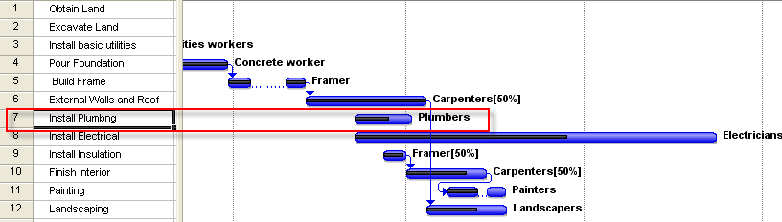

You should notice from the Gantt chart that the task is about 50% complete. The image below shows the Tracking Gantt for the Project.

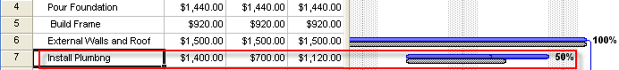

Here you can see that the baseline duration (grey bar) is significantly shorter than the actual duration (blue bar). The information we have seen so far tells us that the task duration has exceeded the original baseline estimates, and still the task has not been completed.

Now let’s look at the EVA table for this project.

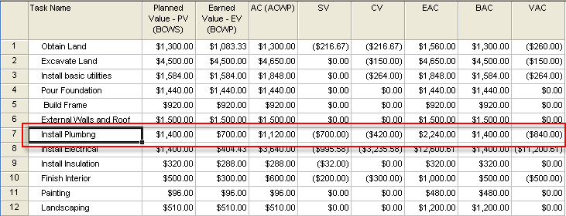

The first column contains BCWS values. From the table, you can see that the BCWS value for task 7 is $1400. This means that the planned cost for this task according to the baseline is $1400.

In the next column you will see the BCWP values. For task number 7 the value in the second column is $700. This means that the task, budgeted for $1400, has only been completed to the $700 dollar mark, based on the original budget. (This is because the task is only about 50% complete.)

In the ACWP column, we see that the value is $1120. This means that actual cost of the work performed (about 50% complete) is $1120. This is because the task has run overdue, that is, it has taken longer to reach the 50% complete mark than it should have. Because it has taken longer, more work related costs have accumulated. Therefore, the actual cost of work performed is higher than the budgeted cost of work performed (BCWP).

In the CV field, you can see the difference (variance) between how much was budgeted for the current level of completion of the task and how much it actually has cost to get to the current level of completion for the task. Remember, negative values are shown in parentheses, so the CV field value for task number 7, which is ($420), is a negative value. This means that the actual cost of the work done to the current completion level is higher than the budgeted cost of the work done to the current completion level. If the CV value was positive, we would be getting the work done for less than what was budgeted.

To add additional EVA fields to the table, you can right click on one of the column headings, and choose Insert Column from the menu.

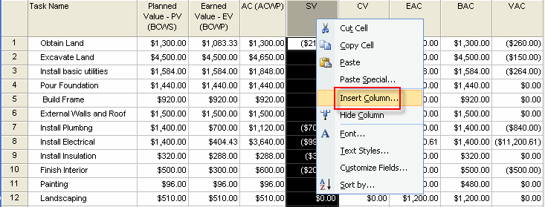

In the resulting Column Definition dialogue, select the desired EVA field from the list of available column headings and click the OK button.

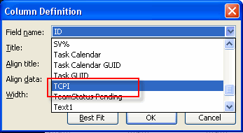

Reporting EVA Results

Project 2010 provides a way to quickly generate a report outlining your project’s EVA. To do this, first select the Project ribbon, click the Reports button located in the Reports group.

In the resulting dialogue, double click the Costs option.

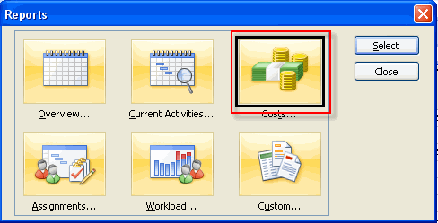

In the Cost Reports box, click on the Earned Value option, and then click the Edit button to edit the report, or the Select button to view it.

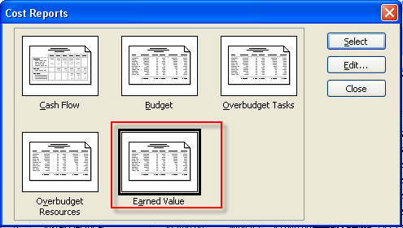

If you click select, you will display the EVA report in the Print Preview window.

Remember, you can use the Page Setup button to make changes to your report before you print it.

